## **Instructions**

Thank you for your interest in joining the Development Team at Northern! As part of the recruitment and selection process, we’d like to ask you to complete the following code challenge. Are you up for the challenge?

A designer has given you the following [mockups](https://sketch.cloud/s/goDVk/zxnwvoW) that you will be asked to turn into a working feature on northern.co. Keep in mind that it should work for everyone (ie. think mobile, cross-browser, etc.)

1. The final result should be live in a service like CodePen, JS Bin, etc. Candidates need to attach the URL with their applications. ([Where to Apply?](https://www.northern.co/careers/))
2. Feel free to use a CSS preprocessor and/or JS Framework/Library. It’s also fine to not use any of these technologies.
3. When submitting the form:
   1. If the email field does not validate, an [error message](https://sketch.cloud/s/goDVk/OmjbrJw) should be rendered.
   2. If the email field is valid, the form should submit and log the value of each field in the browser console without refreshing the page.
   3. It will show a [loading state](https://sketch.cloud/s/goDVk/m1Jovg7) for 2 seconds, to simulate an HTTP request.
   4. It should allow only a single submission. That is, subsequent attempts to submit should be ignored after the initial submission.
   5. After the simulated request, a [“thank you” message](https://sketch.cloud/s/goDVk/DPloxDj) should replace the form without refreshing the page.
4. The grey box within the mockups is only to provide you with the colour and font info that is used, you don’t need to code it into your work.
5. The supported browsers will be the following:

**Desktop**:

* + 1. Latest 2 major releases of Chrome and Firefox, Safari, and Edge
    2. IE 11 Functional

**Mobile**:

* + 1. Latest 2 major releases of Chrome and Firefox, and Safari

[**Form Mockup**](https://sketch.cloud/s/goDVk/4anDeZZ)

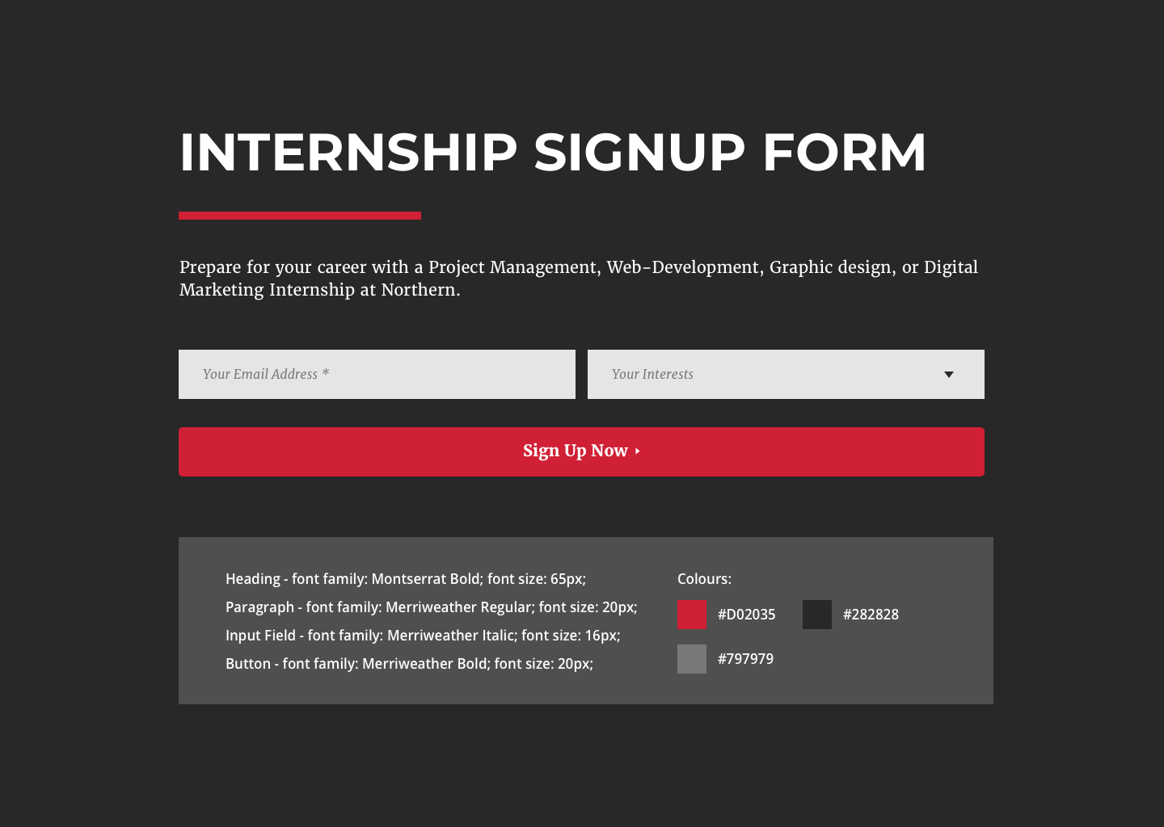

[**Form Error Message**](https://sketch.cloud/s/goDVk/eKnRwGj)

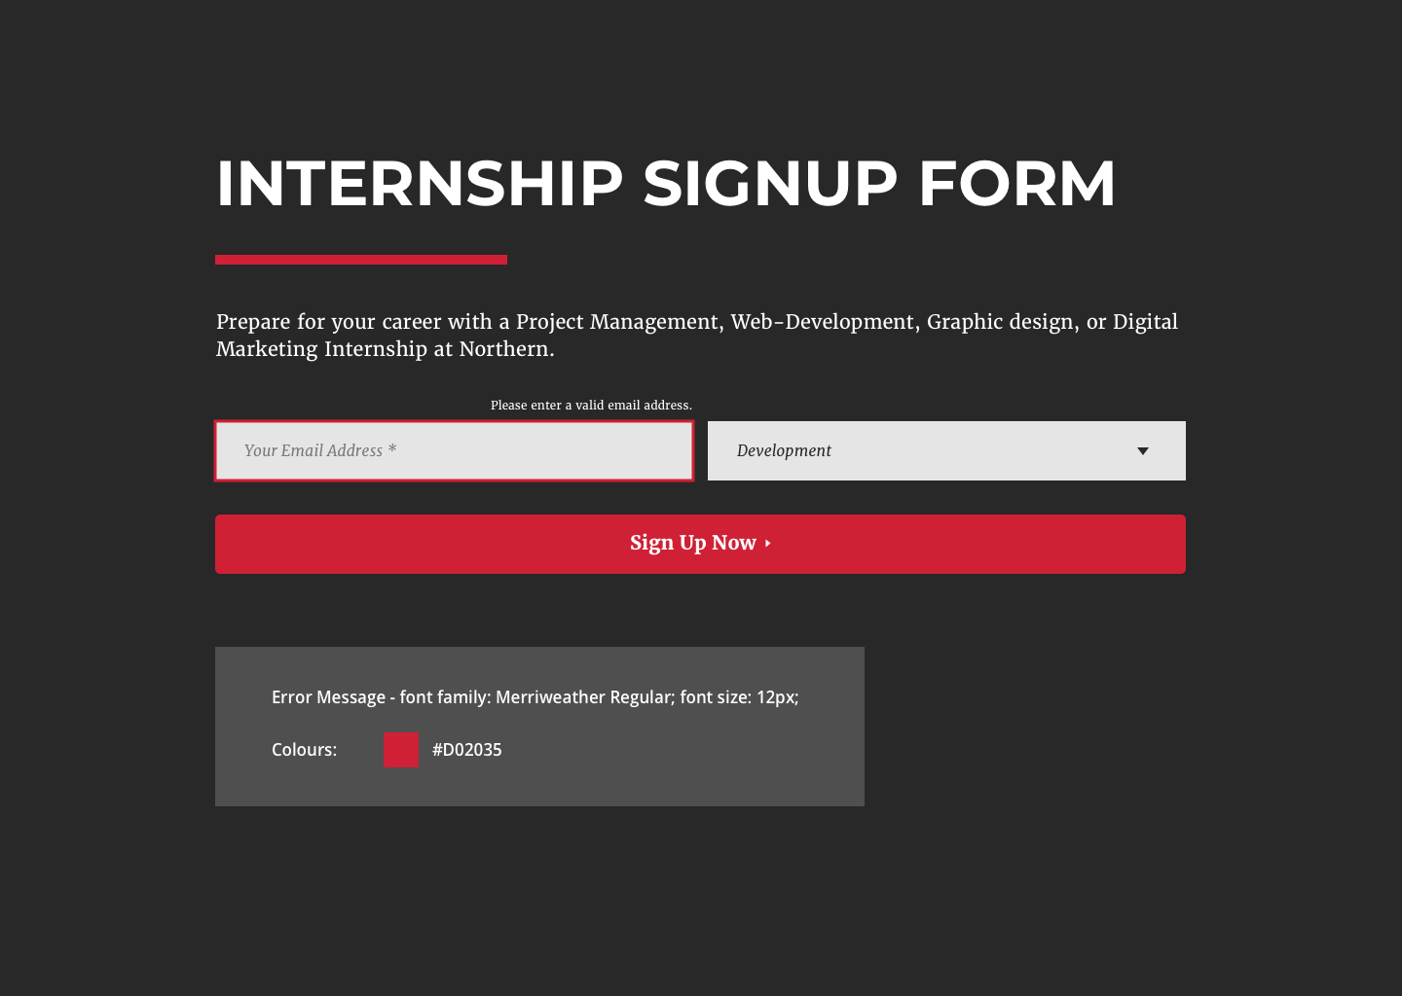

[**Form Submitting**](https://sketch.cloud/s/goDVk/GmWPLQ7)

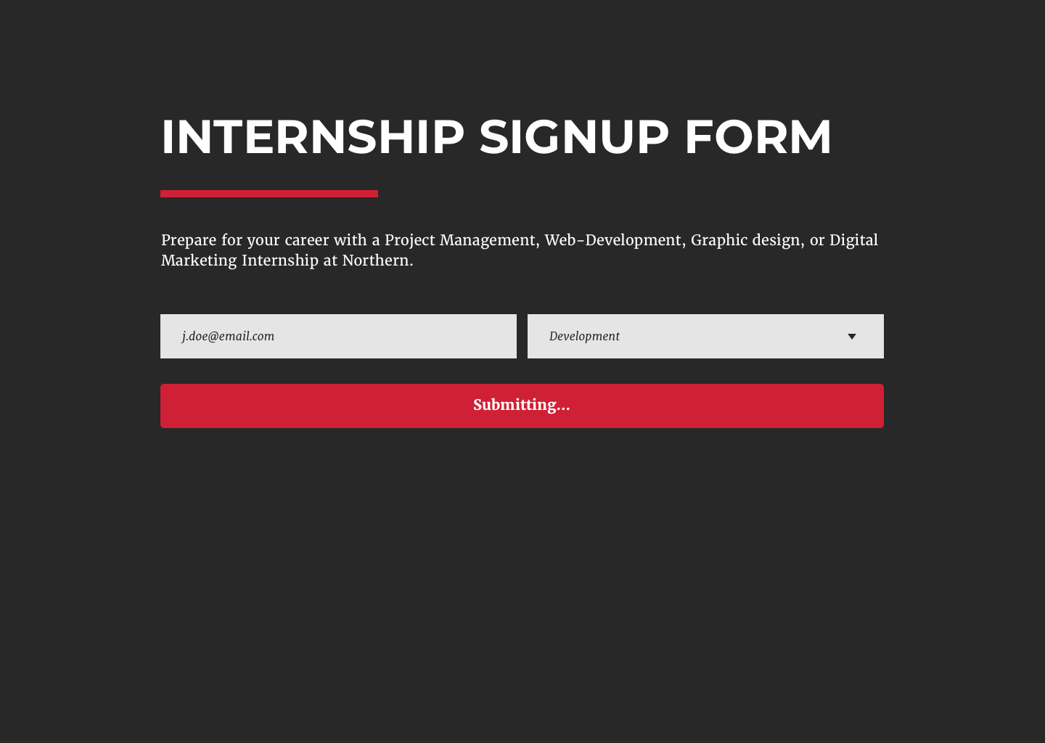

[**After Form submitted**](https://sketch.cloud/s/goDVk/Om43zQ4)

